**Maharshi Patanjali Vidya Mandir Prayagraj**

**HOLIDAYS HOME WORK (2020-21)**

Of

**Class XI- Commerce Stream**

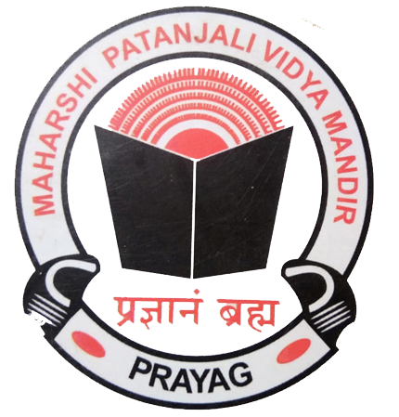



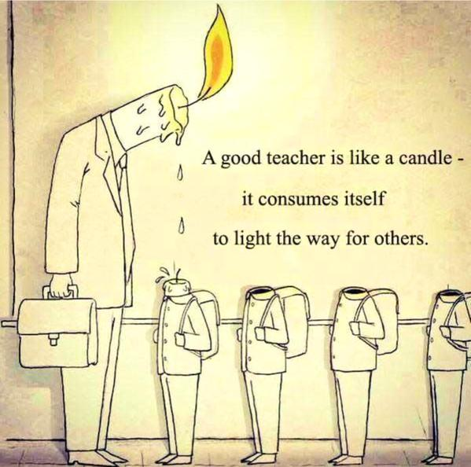



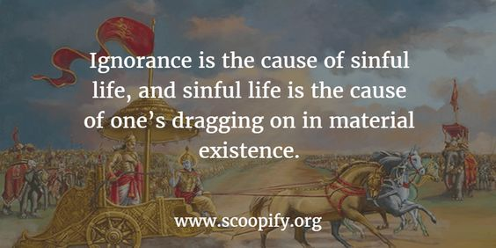

|  |  |  |
| --- | --- | --- |
| **English** | Learn the Question and answers of the following lessons:-  **HORNBILL**   1. The Portrait of a Lady  * A Photograph (poem)   **SNAPSHOTS**   1. The Summer of the Beautiful White Horse   **Practice the exercises on the given topic in**  **Grammar:-**  1.Tenses  **Make a video in pairs, on the topics given:-**  ( please follow these Instructions :-)  *Video should be of 1 minute 30 seconds duration and have to be sent in a compressed format.  * You will speak only on the topics given.  * Keep the video safely as you have to send it to the teachers in July.  **TOPICS FOR ONE AND A HALF MINUTE CONVERSATION**  1.Trying times  2. How to increase our immunity  3. Time Management  4. How I miss my school  5. My Ideal  6. Unpolluted nature- lockdown-lesson  OR  ROLEPLAY: TOPICS (Individual) Keep a hardcopy of the script   1. Policeman 2. Doctor 3. Journalist 4. Army Personnel 5. Teacher 6. Businessman | |
| **Mathematics** | 1. Solve the questions of Set Theory from NCERT and the reference book.  2. Make a list of all the formulae studied in class 10th.  3. Revise the concepts of Algebra and Trigonometry studied in class 10th. | |
| **Accounts** | 1.Revise the chapter Introduction to Accountancy  2. Learn the meaning of basic accounting terms.  3. Do Questions of Accounting Equation.  4. Learn the Basic rules of Accounting. | |
| **Business Studies** | 1. Evolution and Fundamentals of Business   Make notes of various topics covered in class  Complete the exercises given at the back of the chapter and learn  Practise doing case studies related to the topic  Read the chapter “Social Responsibility of the Business” and “Business Ethics”. | |
| **Economics** | **Introductory Micro Economics –**   1. Central Problems of An Economy   Complete all the exercises and the questions given.  Practice doing numerical related to Production Possibility curve, MRT, MOC and Opportunity Cost.  Practice doing the diagrams related to rotation and shifting of PP curve  Read the chapter Consumer Equilibrium.  **Statistics For Economics –**  Read the chapter – Introduction Of Statistics  Learn and write various definitions of Economics, definition of Statistics, both singular and plural, sense, scope importance and distrust of Statistics.  Read the chapter Collection Of Data.  . | |
| **Informatics Practices** | Write down the answers of the following questions.  1. What do you understand by cross platform language/software? Is Python a cross platform language?  2. What are the different working modes in Python? Explain.  3. What are the literals in python? How many types of literals are allowed in python?  4. What is single line string and multi-line string? Explain with example?  5. What is dynamic typing?  6. What will be the output produced by the following code : ➢ X=10 X=X+10 X=X-5 Print(X) X,Y = X-2, 22 Print(X, Y) ➢ X, Y = 20, 60 Y, X, Y = X, Y-10, X+10 Print(X, Y)  7. Write a python program that accepts marks of five subjects as input and produce average of marks as output.  8. A=10 B=20 Write a program to swap the value of A and B by using third variable and print the value of A and B. | |
| **Physical Education** | 1. Revision of unit I 2. Make shorts notes of various topic – (athletic, basketball, football) 3. Practice of Asana ( tadasana, padmasana, Shashankasana) 4. Practice of meditation 5. Practice of home yoga fitness workout daily. | |
| **Legal Studies** | Read unit I from the CBSE e book sent to you  Do all the objective type questions of chapter 1 and 2 from the CBSE book  Revise what was done in the class  Make the legal Studies project  Guide lines for the project  Make a project on any fundamental right  It should include the following headings  Article- Its words, meaning, commentary  Explanation of the Right  Decided cases explain the Right | |
|  | |

“The aim of education should be to teach us rather how to think, than what to think — rather to improve our minds, so as to enable us to think for ourselves, than to load the memory with thoughts of other men.”

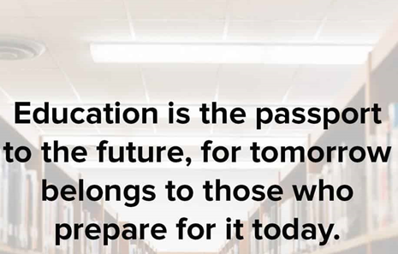

What we learn with pleasure we never forget.”

“Education is the passport to the future, for tomorrow belongs to those who prepare for it today.”

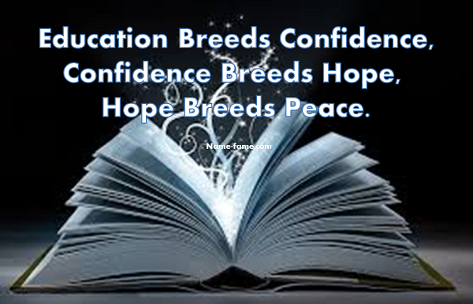

ENJOY YOUR HOLIDAYS